

**SAP Technical Specification**

|  |  |
| --- | --- |
| Project Name | **ME Final Settlement** |
| Customer | **Serco Group** |
| Solution | **Technical Specification** |
| Version | **1.1** |
| Author | **Naresh Palagiri** |
| Date | **24th May 2022** |

Template Control

| Version | Date | Author | Notes |
| --- | --- | --- | --- |
| 0.1 | 13th August 2013 | Malcolm Smith | Created from existing templates |
| 1.0 | 4th Sept 2013 | John Brinkworth | First Issue |
| 1.1 | 3rd Nov 2017 | Karen Bartlett | Addition of new section in Scope (Section 8) to cover the Data Protection Act |

Document Control

| Version | Date | Author | Notes |
| --- | --- | --- | --- |
| 0.1 | 29th April, 2022 | Nithya Ragunathan | Initial Draft |
| 0.2 | 19th May, 2022 | Nithya Ragunathan | First Draft |
| 0.3 |  |  |  |
| 1.0 |  |  |  |

Document Location

| Location |
| --- |
|  |

Approval

| Name | Role | Date | Signature |
| --- | --- | --- | --- |
|  |  |  |  |

Distribution

| Name | Role |
| --- | --- |
|  |  |

1 Overview 4

1.1 Overview 4

1.2 SCOPE 4

1.3 Assumptions 4

1.4 System Functional Area 4

1.5 Transaction Volumes 4

1.6 Frequency & Timing 4

1.7 Processing Type 4

1.8 Output Device 4

1.9 Security Requirements 4

1.10 Constraints 4

1.11 Dependencies 4

2 Technical Solution (ABAP Enhancements) 5

3 Annex A – Product Description (reference only) 7

# Overview

## Overview

## To update Middle East Final Settlement Calculator Tool with inputs from SAP Leavers report.

## SCOPE

## Inorder to help the payroll team with all the required details, the existing SAP leavers would be copied, and the copied version will be modified to report on all the required data

## Assumptions

No Assumptions

## System Functional Area

HD3

## Transaction Volumes

N/A

## Processing Type

NA

## Output Device

N/A

## Security Requirements

N/A

## Constraints

N/A

## Dependencies

N/A

# Technical Solution (ABAP Enhancements)

Existing Program: ZP_RHR_LEAVER_REP_ME

New Program : ZP_RHR_LEAVER_REP_ME_FS

Selection Screen: 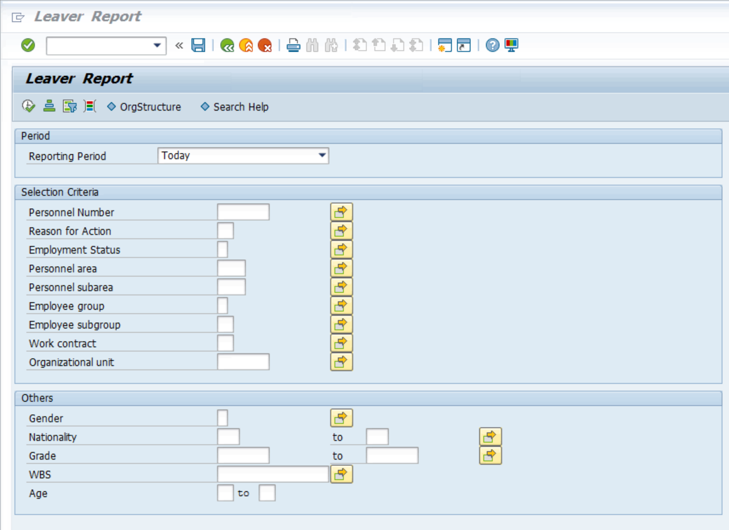

**Input Parameters:**

|  |  |  |  |  |  |
| --- | --- | --- | --- | --- | --- |
| **Sr. No.** | **Object Name** | **SAP Field Name (RFC)** | **Object Field Name (SAP Standard Structure)** | **Key Field** | **Field Comments** |
| 1 | Personnel Number | PERNR | PA0000 – PERNR | N | If not provided select all the Pernr’s available in the system |
| 2 | Reason for Action | MASSG | PA0000-MASSG | N | If not provided select all the Pernr’s available in the system |
| 3 | Employment Status | STAT2 | PA0000-STAT2 | N | If not provided select all the Pernr’s available in the system |
| 3 | Personnel Area | WERKS | PA0001-WERKS | N | If not provided select all the Personnel areas available in the system |
| 4 | Personnel Subarea | BTRTL | PA0001-BTRTL | N | If not provided select all the Personnel Subarea available in the system |
| 5 | Employee Group | PERSK | PA0001-PERSK | N | If not provided select all the Employee Groups available in the system |
| 6 | Employee Sub-group | PERSG | PA0001-PERSG | N | If not provided select all the Company Code available in the system |
| 7 | Work Contract | ANSVH | PA0001-ANSVH | N | If not provided select all the Work Contract available in the system |
| 8 | Company Code | BUKRS | PA0001 – BUKRS | N | If not provided select all the Company Code available in the system |

In addition to the above selection fields, the program would also include the key date for the reporting period. It would also include other field options like Gender, Nationality, grade, WBS and age.

**Output Parameters:**

| **Sr. No.** | **Object Name** | **Object table and Field Name (SAP)** | **Additional Consideration for data extraction** |
| --- | --- | --- | --- |
| 1 | Personnel Number | PA0000 – PERNR |  |
| 2 | Personnel Name | PA0001- ENAME |  |
| 3 | EE Notice Period | PA0016 – KDGF2 |  |
| 4 | EE Group | PA0001-PERSG |  |
| 5 | Organizational Unit | PA0001-ORGEH |  |
| 6 | Employee Subgroup | PA0001-PERSK |  |
| 7 | Personnel Subarea | PA0001-BTRTL |  |
| 8 | Name of Manager (OM) |  | Use existing function module to pick the manager “ZHCM_LINE_MANAGER_MIM” |
| 9 | Lv (Grade) | PA0008-TRFGR |  |
| 10 | Basic Salary | PA0008 – LGART | WT 1000 value to be picked |
| 11 | Crcy | PA0008-ANCUR |  |
| 12 | Initial Hire Date | PA0041-DAR01 |  |
| 13 | Start Date | PA0041-DAR01 |  |
| 14 | End Date |  | Default 31.12.9999 |
| 15 | Reason for Action | PA0000-MASSG |  |
| 16 | Continuous Date type | PA0041-DAR02 |  |
| 17 | Housing Allowance | PA0014-BETRG | Only WT 2304 value to be picked |
| 18 | Transport Allowance | PA0014-BETRG | Only WT 2308 value to be picked |
| 19 | Special Allowance | PA0014-BETRG | Only WT 2316 value to be picked |
| 20 | Utility Allowance | PA0014-BETRG | Only WT 2307 value to be picked |
| 21 | National Allowance | PA0014-BETRG | Only WT 2314 value to be picked |
| 22 | OJTI Allowance | PA0014-BETRG | Only WT 2310 value to be picked |
| 23 | Fixed Overtime Allowance(3104) | PA0014-BETRG | Only WT 3104 value to be picked |
| 24 | Housing Loan Balance | PA0045-OPELO |  |
| 25 | Housing Loan End Date | PA0045-DLEND |  |
| 26 | Relocation Allowance Loan Balance | PA0045-OPELO |  |
| 27 | Relocation Allowance End Date | PA0045-DLEND |  |
| 28 | Salary Adv Balance | PA0045-OPELO |  |
| 29 | Salary Adv End Date | PA0045-DLEND | End date |
| 30 | Notice Start Date: | PA0041-DAR02 | Date type M5 to be picked up |
| 31 | Last Date of Working: | PA0041-DAT05 | Date type Z7 to be picked up |
| 32 | Last Annual Airfare Paid date | PA0015-BEGDA | Pick up the Start date of WT 6001 |
| 33 | Last Annual Airfare Amount | PA0015-BETRG | WT 6001 to be picked up |

**Unit testing document**



# Annex A – Product Description (reference only)

|  |  |
| --- | --- |
| **Product Description** | |
| **What?** | The SAP Technical Specification is a detailed description of the technical development required to meet the needs identified in the related Functional Specification. |
| **Why?** | The benefits of completing a SAP Technical Specification are:   * To provide a clear documentation of what has been developed in the system, and why. * To help future support and maintenance of the system. |
| **Who?** | The Developer is responsible for:   * Documenting the technical development requirements.   The Project Manager is responsible for:   * Ensuring that a Technical Specification document is completed for each development. |
| **When?** | The Technical Specification should be completed in the Design Stage:  Dependencies:  The Technical Specification should be delivered with the following considerations:   * Design of the Functional Specification. |
| **Hints and Tips** | N/A |
| **Next Steps** | Once completed you should consider the following products or actions:   * Testing |